**Department of Technical Education**

**Capstone project**

**Format- 2**

**Work Breakdown Structure**

Capstone project Name:

E-Commerce Online Medicine Shopping

Capstone project Members:

Darshan Ghatge [339CS20010]

Rakshita Jadhav [339CS20020]

Smital Kaginkar [339CS20027]

Sufiyan Goundi [339CS20031]

Capstone project Objective(s):

* User can order medicine anytime.
* **Information is private and confidential**
* **Convenient**
* Easy to use, update and maintain
* **Time-saving**

## Work Breakdown Structure – Deliverables

* In this project there are two main modules Admin and User.
* Admin Modules
* Admin Login -Using user name and password admin can login to this project.
* Manage Categories - Admin can manage the categories.
* Manage Products - Admin can manage the products (add and delete).
* View Orders -Admin can view the list of orders.
* Offers - In this module admin gives offers to the product.
* User Modules
* User Registration -In this module user can registration with the details.
* User Login - In this module user can login with his details.
* View Products - In this module user can view the list of products.
* Order Products - this module user can send the product orders.
* View Offers - In this module user can view the offers.

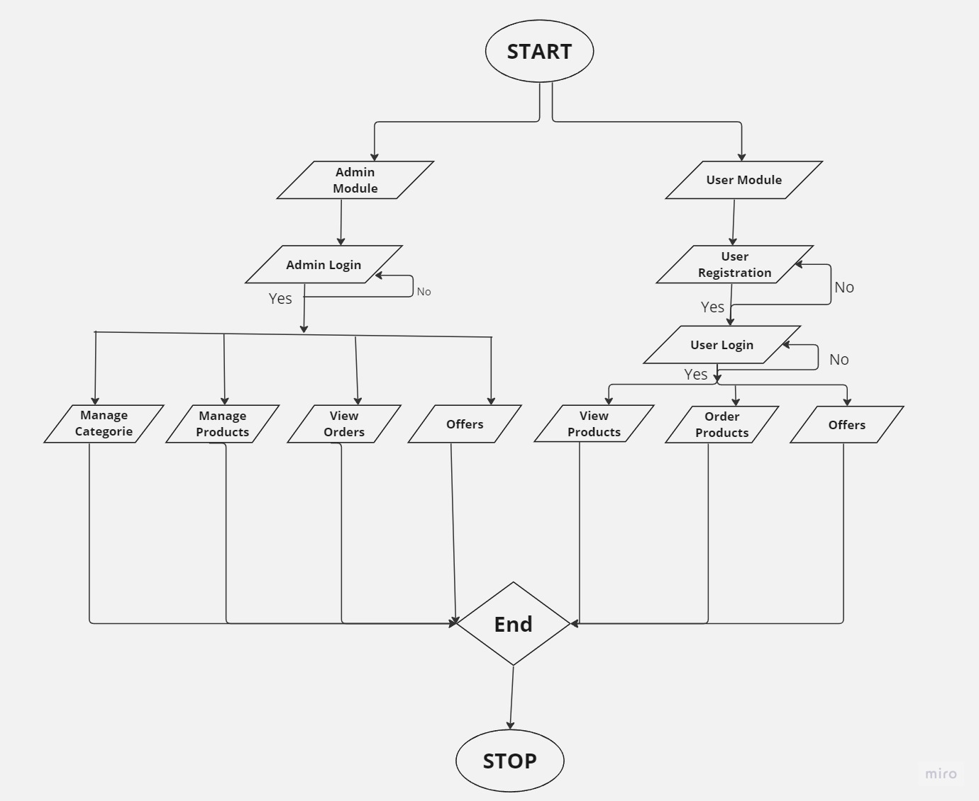Flowchart :

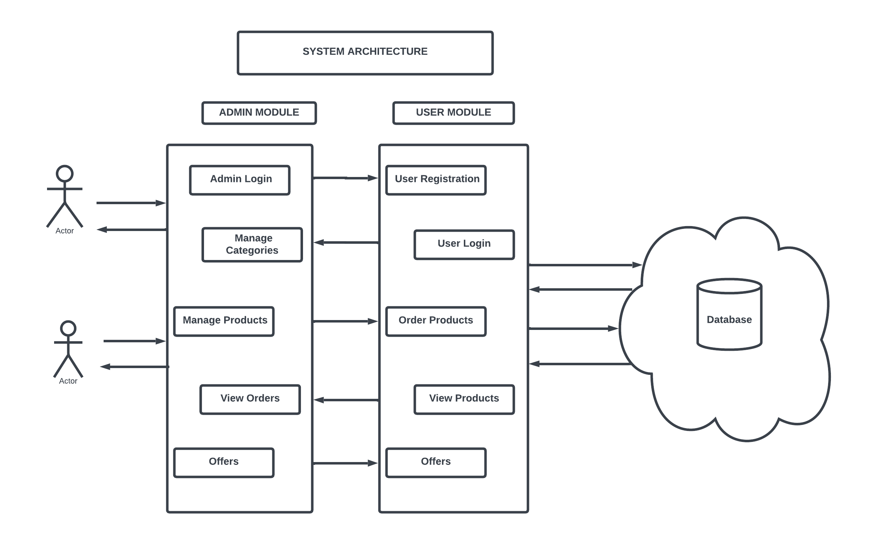

System Architecture Diagram

Activities & Task

1. Admin login (31hrs)

* Admin must login with correct details for easy access (task)
* Admin must login according to the parameters given for the validation (task)

2. Manage Categories (35hrs)

• Admin must manage categories according to products. (task)

• Products must be added according to their respective category(task)

3. Manage Products (35hrs)

* Admin adds the product to the website. (task)

• Admin must manage the products by checking the stock of products (task)

4.View Orders(44hrs)

• Admin must view the list of orders (task)

* Admin must deliver the products according to the order list(task)

5. Manage Offer’s (36hrs)

• Admin must manage the offers on the products (task)

* User must get offer’s on the products. (task)

6. User Registration (42hrs)

• User must register using their correct details. (task)

* User must register according to the parameters given for the validation. (task)

7. User Login (38hrs)

• User must login using their correct details. (task)

* User must login according to the parameters given for the validation. (task)

8.View Products (49hrs)

• User can view the product’s as per their requirements. (task)

* The correct description of the product must be displayed according to the products. (task)

9.Order Products (50hrs)

* The order list of the products must be displayed according to orders.(task)

• Orders must be successful added to the cart(task)

Date Signature of the student Signature of the cohort owner